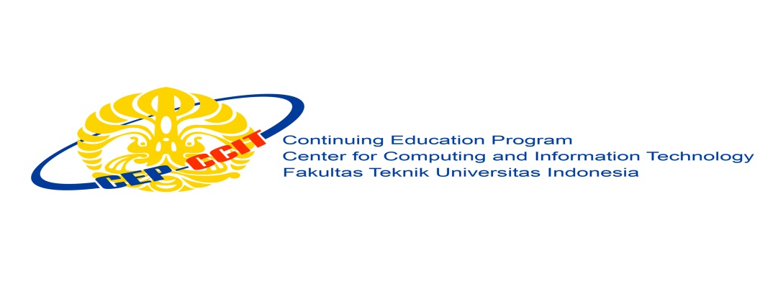

**PROJECT 2**

**“Cinema Ticket Reservation”**

Written by :

**Raden Mas Yudhistira Nuzuli Ardana (2020010086)**

**Siti Rayhannah (2020010094)**

**Virgi Febrian Hermawan (2020010102)**

Group : **4**

Lecturer :

**Listyo Edi Prabowo, ST**

Class :

**2SC5**

**CEP CCIT - Fakultas Teknik Universitas Indonesia**

**Gedung Engineering Center Lt. 1, Kampus Baru UI Depok 1642**

**Developed by**

Name :

**Bobby Ibnu Perkasa** (1820010045)

**Dimas Arsyad Hidayat** (1820010055)

**Millenia Saharani** (1820010122)



**PROJECT ON**

EMPLOYEE ATTENDANCE APPLICATION

Batch Code : 2SC5

Start Date : April 21st, 2021

End Date : April 23th, 2021

Name of the Coordinator : Mr. Listyo Edi Prabowo, ST

Names of Developer :

- Raden Mas Yudhistira Nuzuli Ardana

- Siti Rayhannah

- Virgi Febrian Hermawan

Date of Submission : April 22th, 2021

Date of Approval : April 22th, 2021



**Cinema Ticket Reservation**

**CERTIFICATE**

This is to certify the report, titled **Cinema Ticket Reservation** embodies original work done by Raden Mas Yudhistira Nuzuli Ardana, Siti Rayhannah, and Virgi Febrian Hermawan in fulfilling the project assignment in CCIT-FT UI.

Coordinator,

**Mr. Listyo Edi Prabowo, ST**



Praise be to the presence of Allah, SWT. who has helped us in making this project because without the pleasure of it we will not be able to make this project. we also thank to Mr. Listyo Edi Prabowo as our lecturer and mentor in making this second project entitled **Cinema Ticket Reservation** Hopefully what we have made can be useful in the future.

Best Regards,

**Authors**



**ACKNOWLEDGEMENT**

**SYSTEM ANALYSIS**

**System Summary :** The Python programming language is a computer programming language that can be used to create various applications (general-purpose programming language). In this paper we will discuss about "Cinema Ticket Reservation" which in making this program uses the Python language. This project about programming in the existing ordering system cinema contains the menu and transaction.

**APPLICATION DESIGN**

**Application name :** Cinema Ticket Reservation

**Number Of Menu :** 1. Mengisi nama

2. Pilih usia

3. Pilih film

4. Pilih Jadwal

5. Pilih kursi

6. Total pembayaran

6. Invoice

**FLOWCHART**

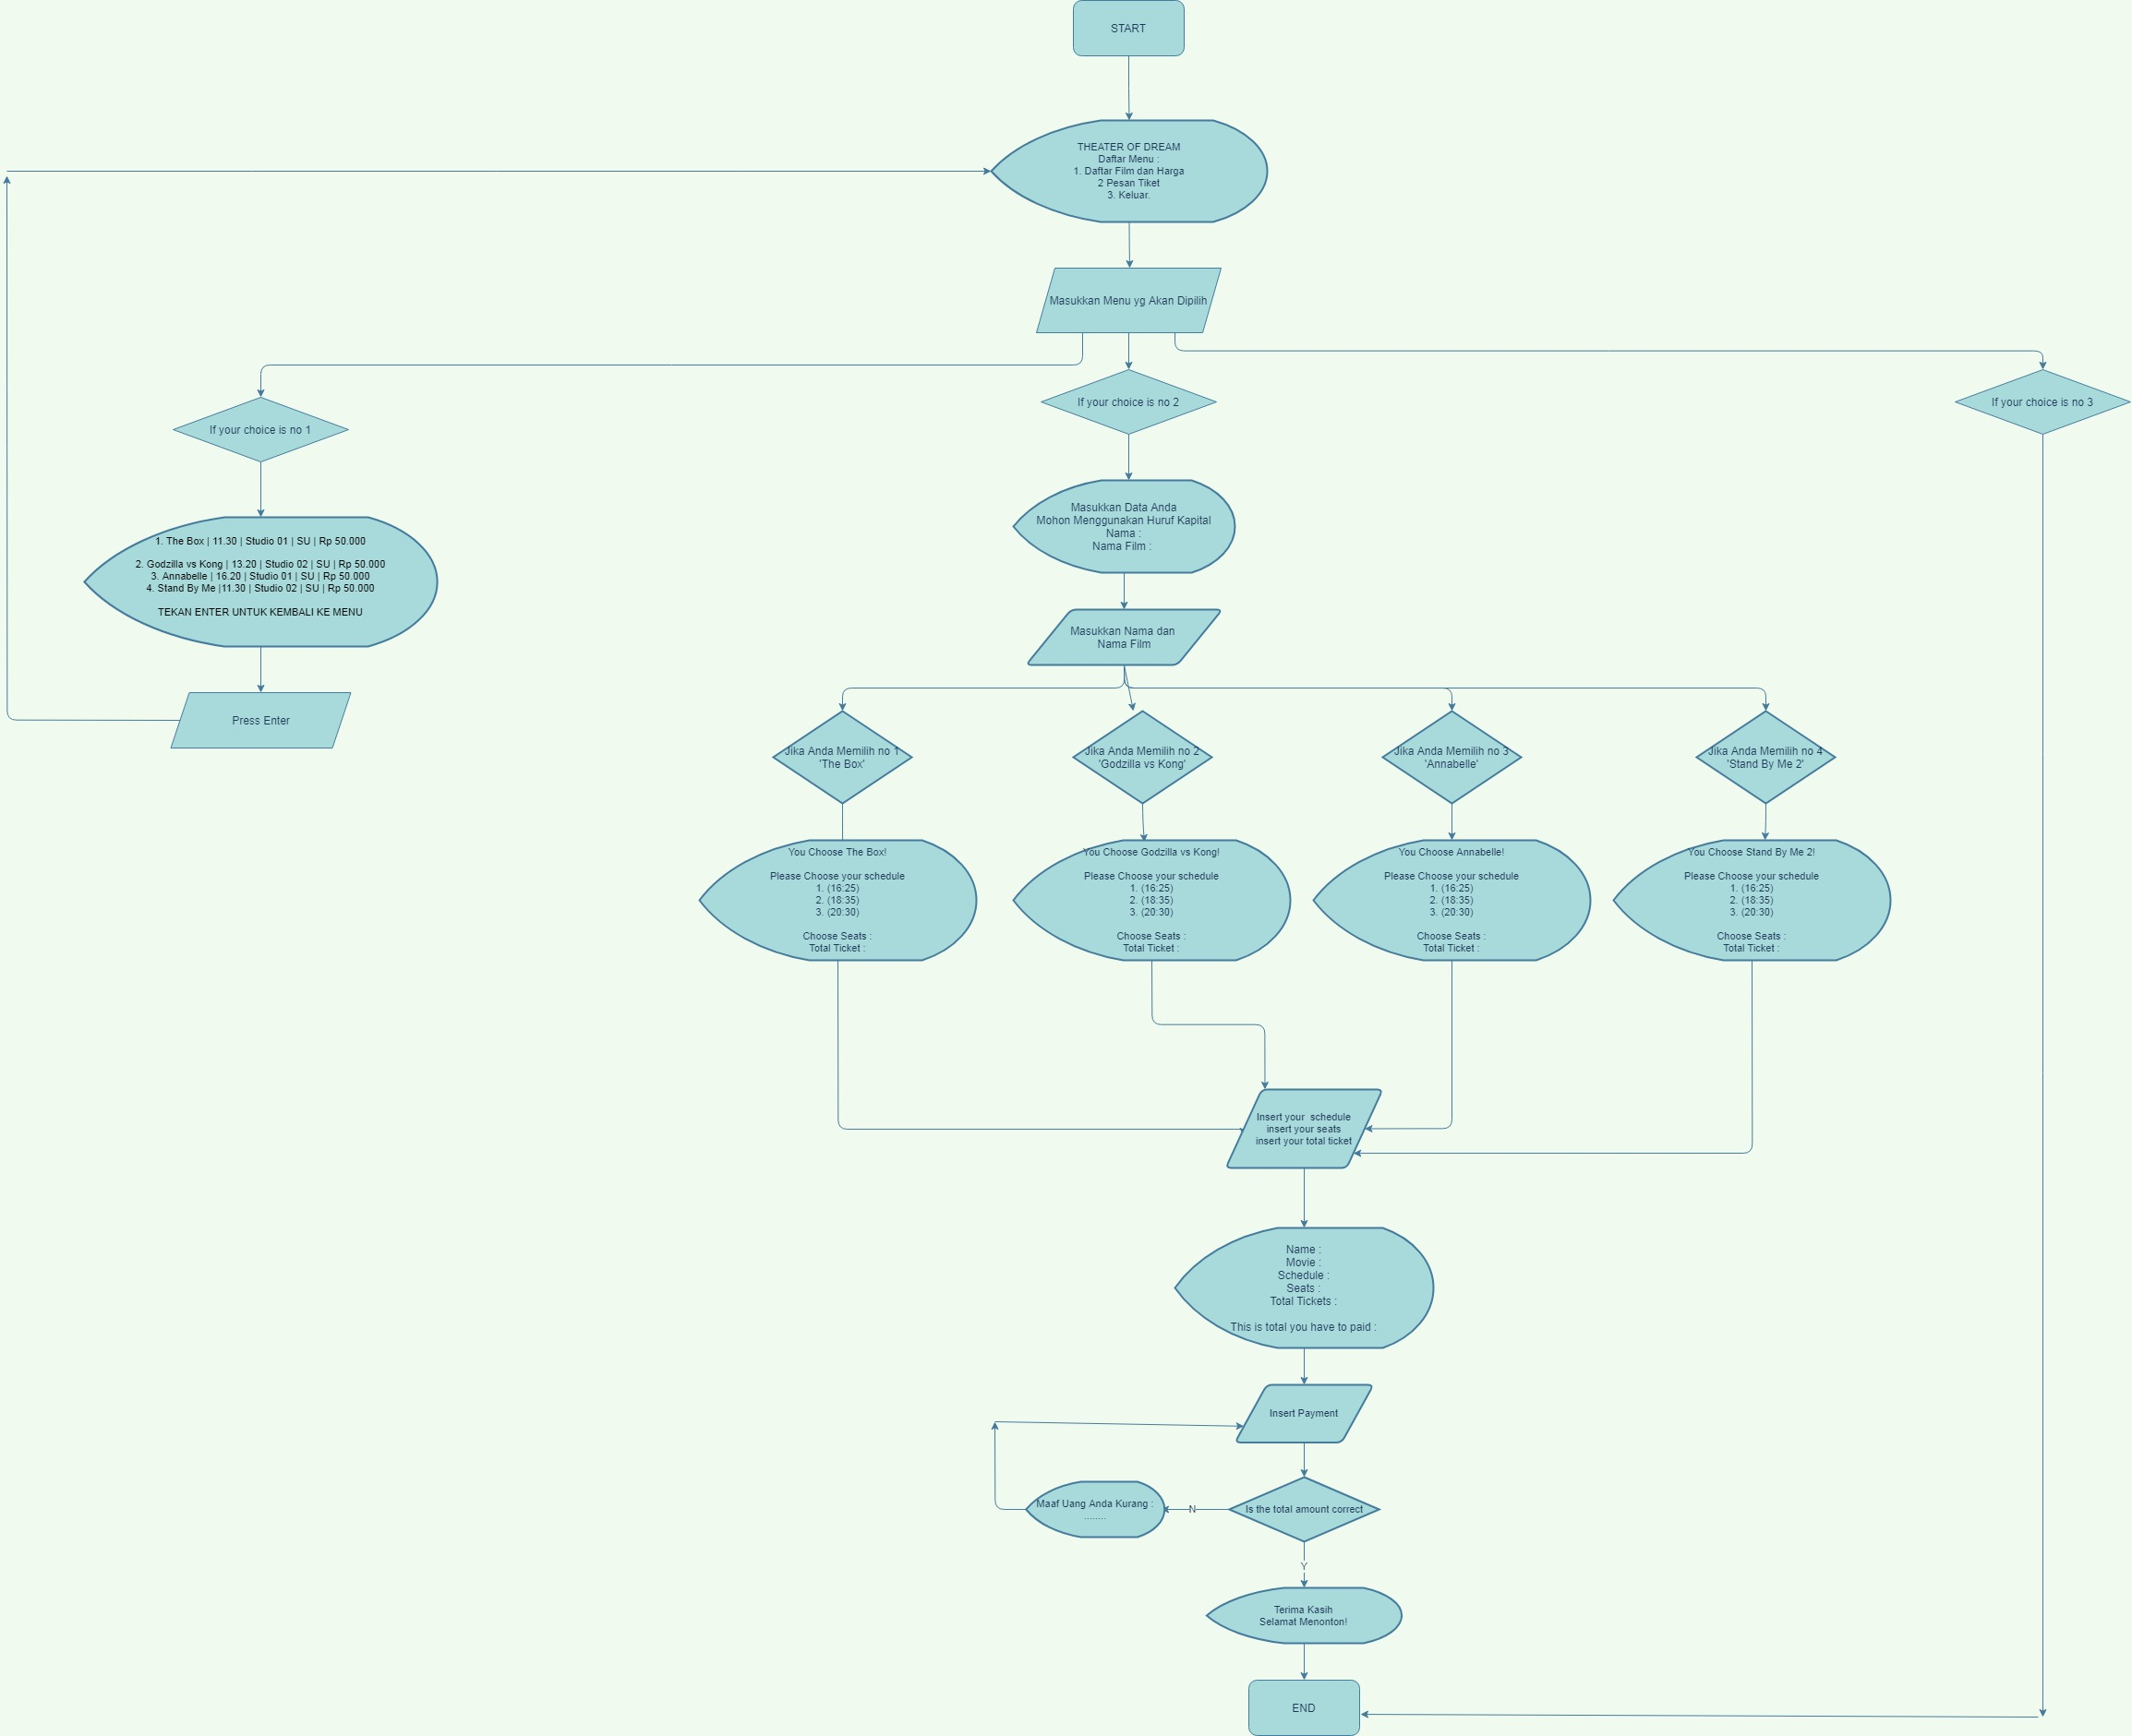

**SOURCE CODE**

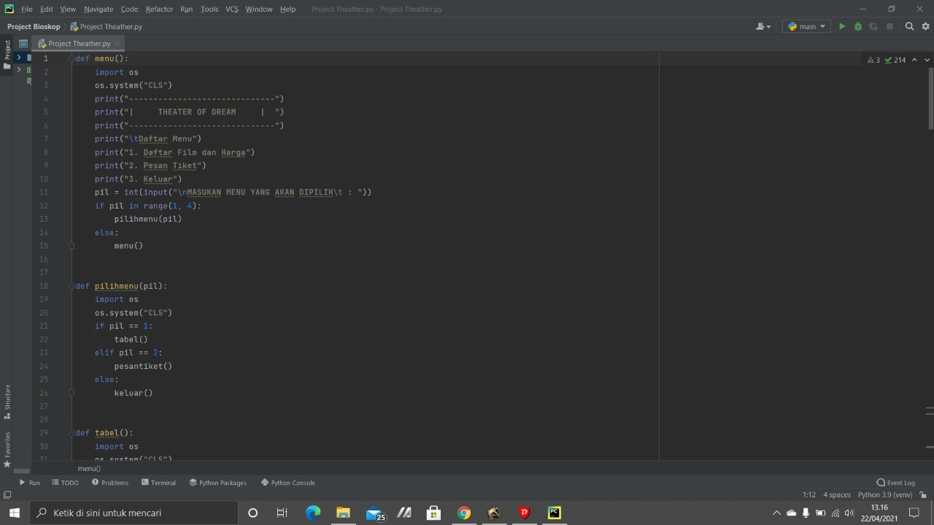

**SOURCE CODE**

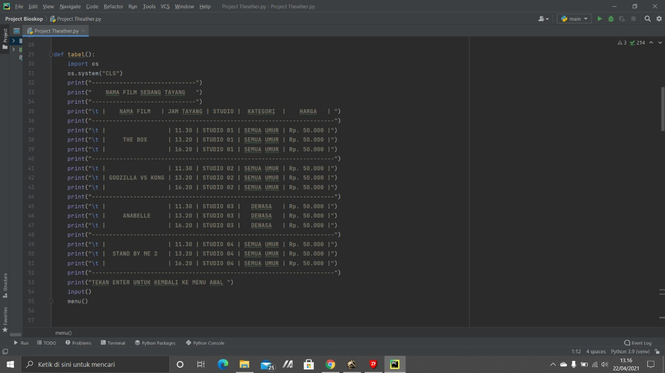

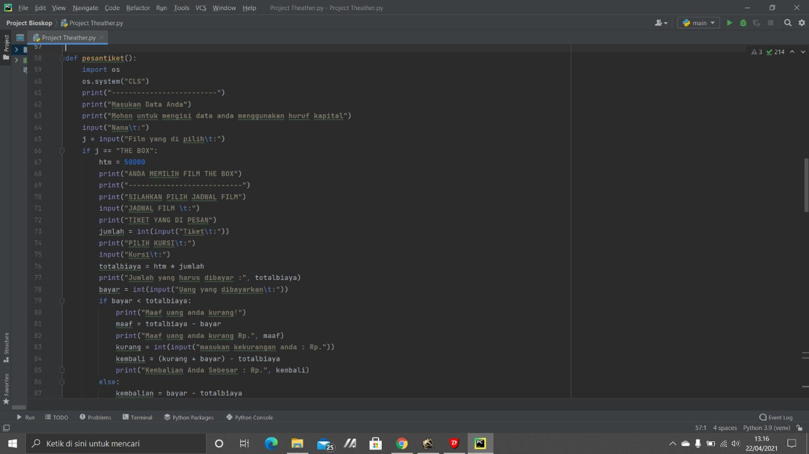

**SOURCE CODE**

**SOURCE CODE**

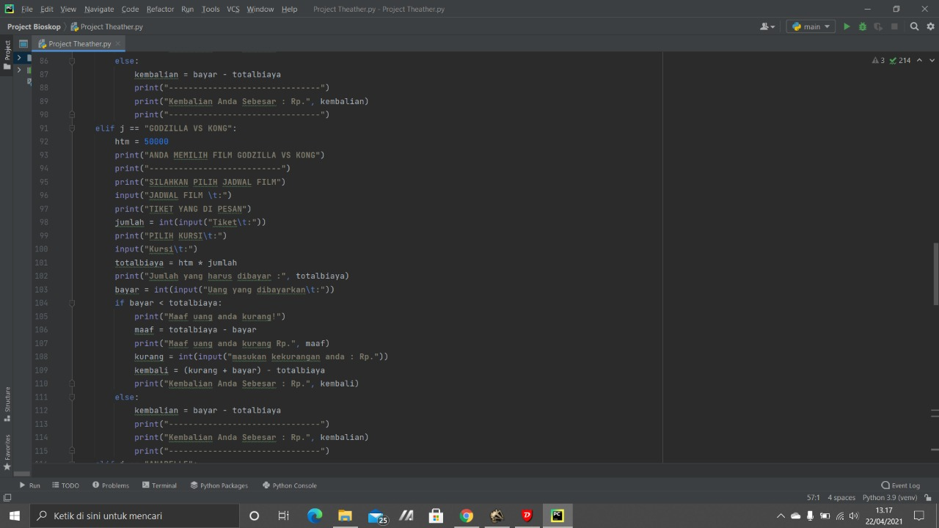

**System Process : Declaring Module**

This pseudocode represents the main system declare.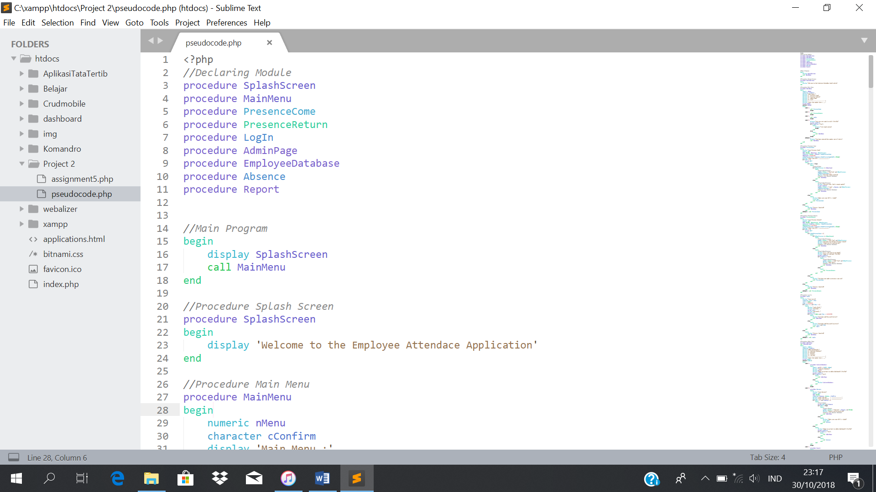

**System Process : Main Program**

This pseudocode represents the main program.



**System Process : Splash Screen**

This pseudocode represents the Splash Screen Procedure.



**PSEUDOCODE**

**SOURCE CODE**

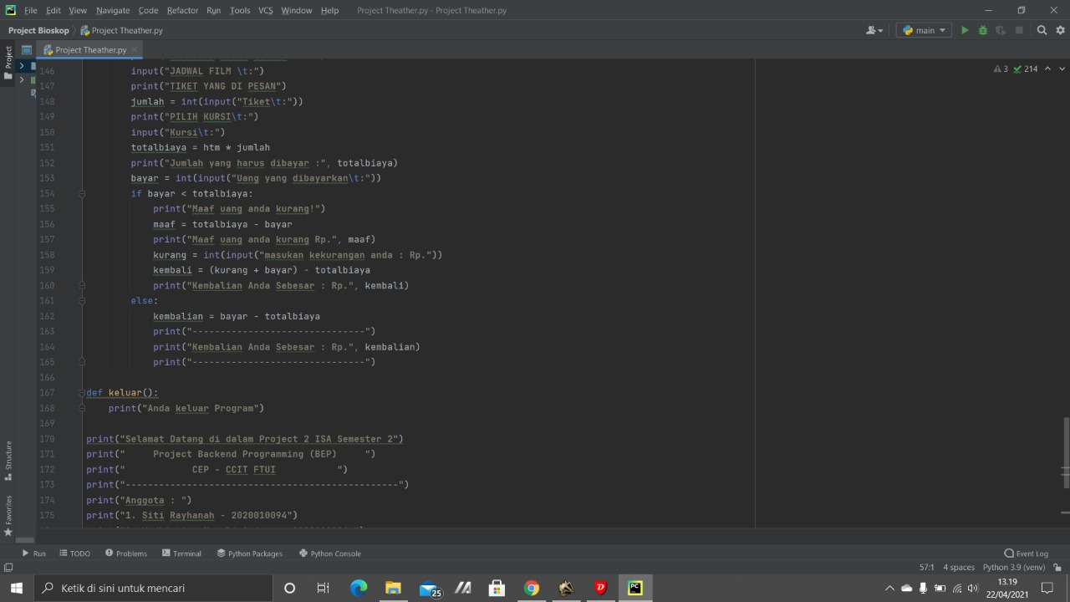

**SOURCE CODE**

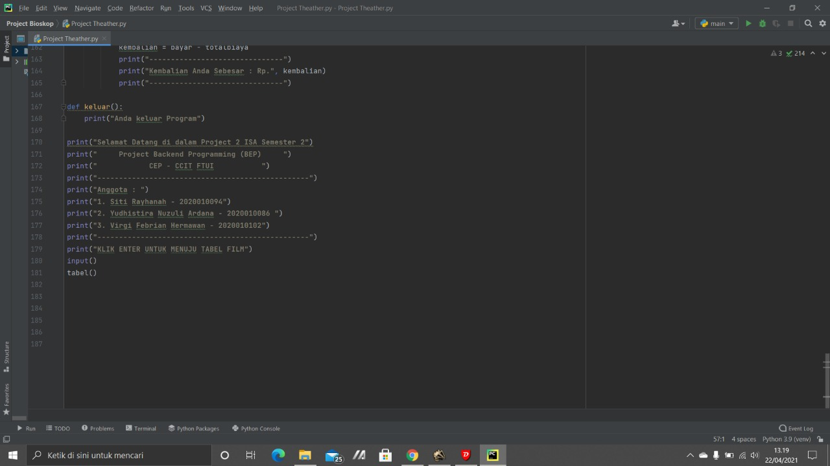

**OUTPUT**

the customer chooses the movie. Then will appear the movie schedule and the customer must choose the movie schedule.

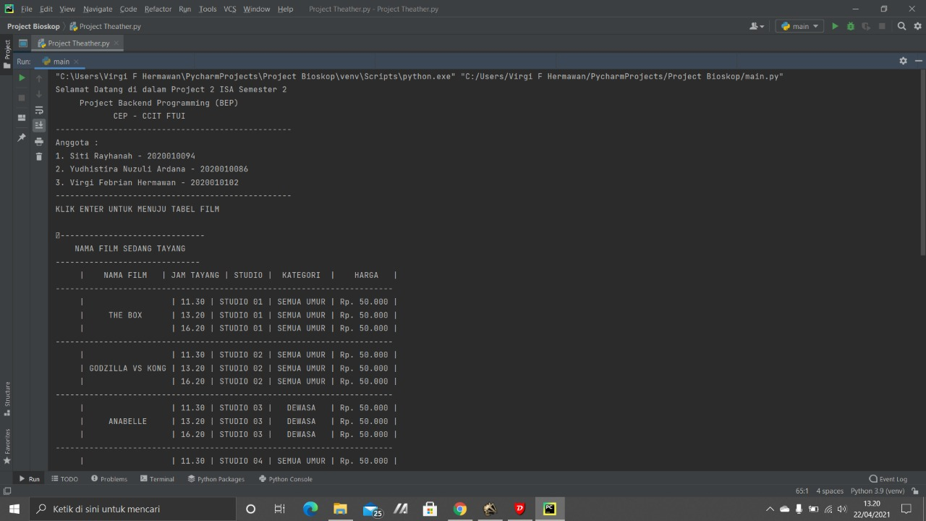

**OUTPUT**

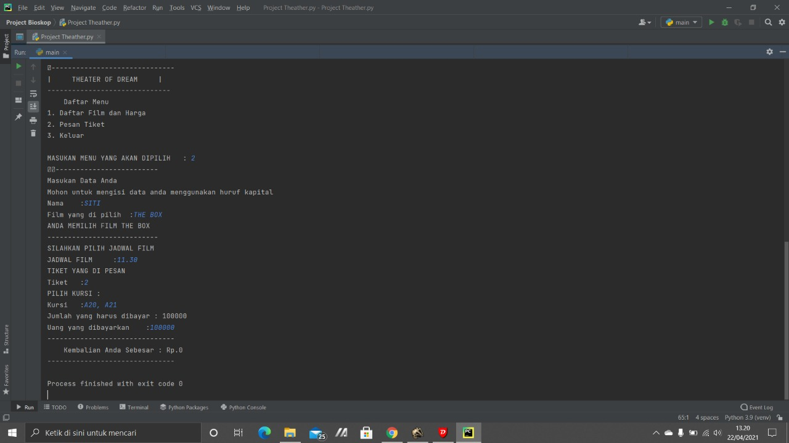

The customer choose the movies, seats , and amount of tickets. And Then appear the total that the customer have to paid

If the customers wants to re order the tickets then the customer have to press enter but if don’t wanna re order then no need to press enter

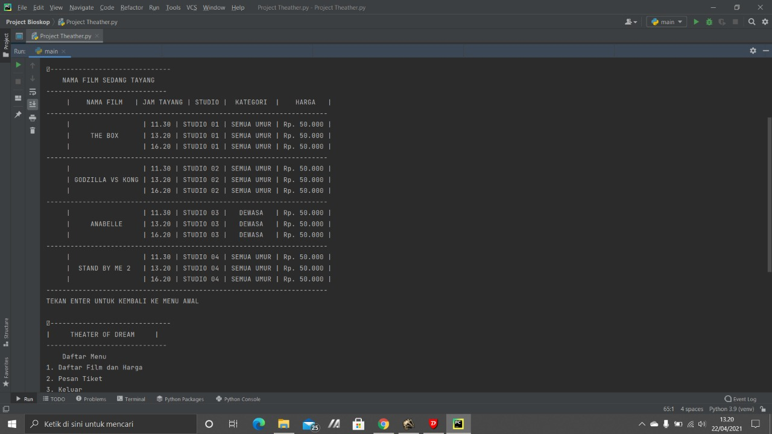

**OUTPUT**

**CONFIGURATION**

**Hardware :** AMD A8-7410 APU with AMD Radeon R5 Graphics 2.20 GHz, 4.00 GB, 64-bit operating system, x64-based processor

**Operating System :** Windows 10

**Software :** Pycharm python ( Source Code )

Microsoft Word ( Project Report )

|  |  |  |
| --- | --- | --- |
| **PROJECT FILE DETAILS** | | |
| **No** | **File Name** | **Remarks** |
| 1 | Project Theater.py | Pycharm that contains Source Code |
|
|
| 2 | CinemaTicketReservation.Doc | Microsoft Word that contains Project Report |

**ACTIVITY LIST**

|  |  |  |  |
| --- | --- | --- | --- |
| No. | Activity | Date | PIC |
| 1 | Analyze the project and Collecting data | April, 21st 2021 | All |
| 2 | Make a coding | April, 21th 2021 | Virgi Febrian Hermawan |
| 3 | Power Point | April, 22th 2021 | Siti Rayhannah |
| 4 | Word | April, 22th 202 | Raden Mas Yudhistira Nuzuli Ardana |